Execise 3:
- SELECT * FROM employee_data WHERE l_name LIKE 'P%';
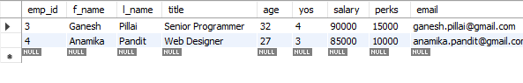 2. SELECT f_name, l_name, title FROM employee_data WHERE title LIKE 'Marketing%';

3. 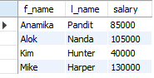
4. SELECT l_name, title FROM employee_data WHERE title IN ('Senior Programmer', 'Programmer', 'Multimedia Programmer');


